# Binary Search

**Q. Given an array arr of n integers and an integer x.**

**Write C++ program to find any position i such that arr[i] = x. If x is not present in the array, i = -1. Print i.**

For eg:

Input:

arr=[2, 5, 1, 4, 7], x=4

Output:

3

| int pos=-1; for(int i=0; i<n; i++) {  if(arr[i]==x)  {  pos=i;  break;  } } cout<<pos; |
| --- |

This is called **linear search**.

Time complexity: O(n) [ Worst case time complexity ]

**Q. Given an array arr of n integers and an integer x. Array arr is sorted in non-decreasing i.e arr[i] <= arr[i+1].**

**Write C++ program to find any position i such that arr[i] = x. If x is not present in the array, i = -1. Print i.**

mid = (0+9)/2 = 4

mid = (5+9)/2 = 7

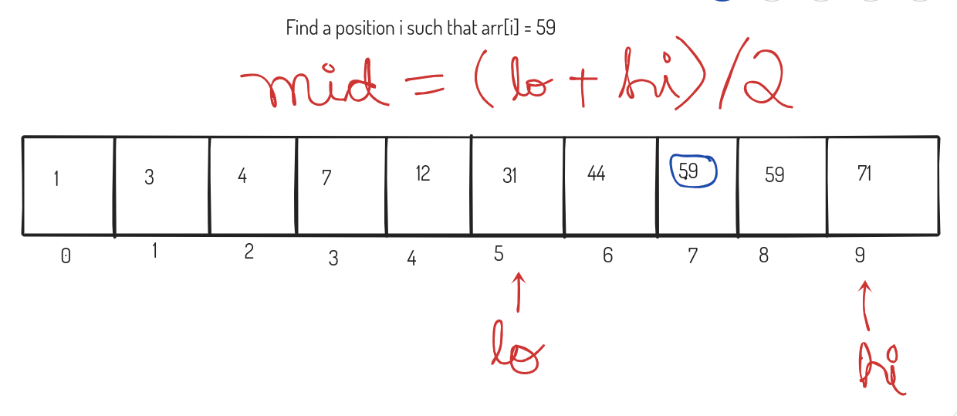

(0+3)/2 = 1

(2+3)/2 = 2

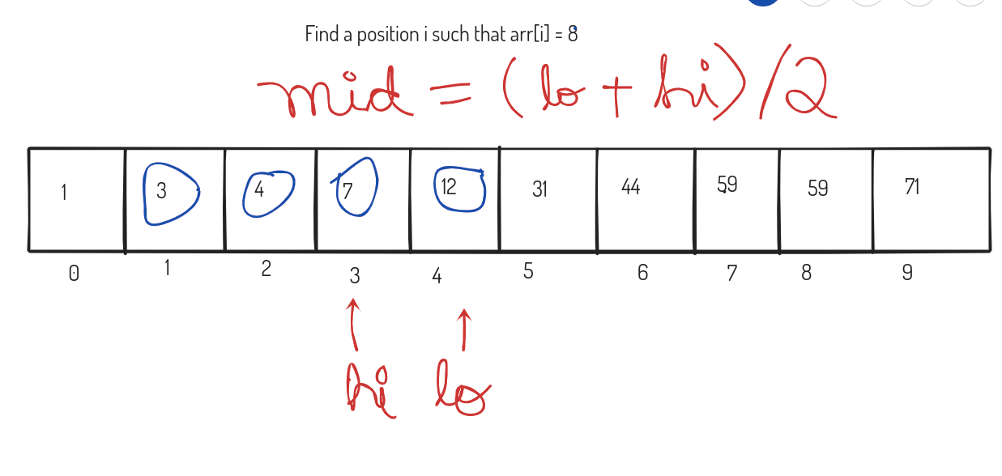

Code:

| int lo=0, hi=n-1; int mid; int pos=-1; while(lo <= hi) {  mid = (lo+hi)/2;  if(arr[mid]==x)  {  pos=mid;  break;  }  else if(arr[mid]<x)  {  lo = mid +1;  }  else {  hi = mid - 1;  } } cout<<pos; |
| --- |

This is called **binary search**.

Time complexity: O(log N) [ At every step, active region of search reduces by half ]

n => n/2

n/2 => n/4

n/4 => n/8

…..

1

n/(2^i) = 1

It will be O(log N)

To calculate the middle element, the above formula mid = (lo+hi)/2, then overflow may occur.

**So, you should always use this formula to calculate middle element:**

**mid = lo + (hi-lo)/2;**

**or**

**mid = lo + (hi-lo+1)/2;**

**Q. Which of the following is a monotonic function?**

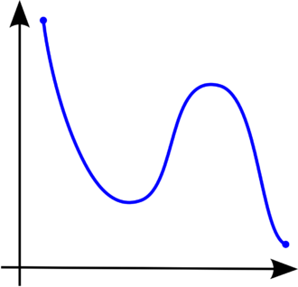

Function a

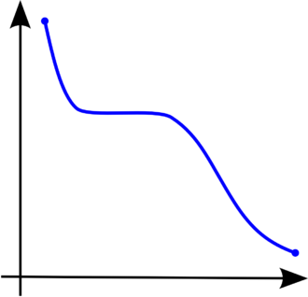

Function b

Function b is a monotonic function because in the whole interval, it is non-increasing

Function a is not monotonic because it first decreases, then increases and then again decreases.

**Note: Binary search can always be applied only on monotonic functions. [ IMPORTANT ]**

**Q. Given an array arr of n integers consiting of 0's and 1's and all the 1's are after all the 0's, find the position of the first 1.**

The array elements are monotonically non-decreasing, so we can apply binary search here.

Eg:

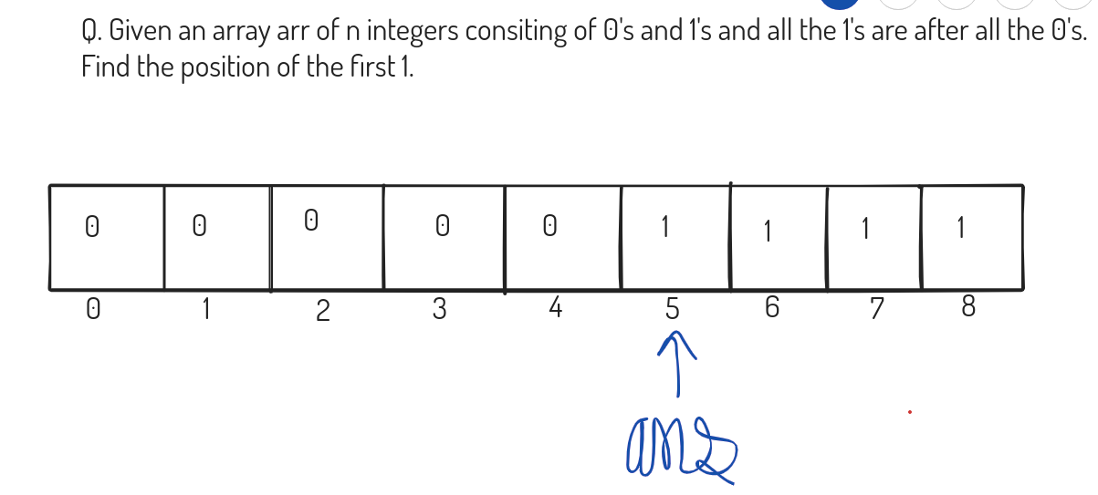

Code:

| int lo=0,hi=n-1; int mid; int ans=-1; while(lo<=hi) {  mid = lo + (hi-lo)/2;  if (arr[mid] == 0)  {  lo = mid+1;  }  else   {  ans = mid;  hi = mid-1;  } } cout<<ans; |
| --- |

Q. <https://codeforces.com/edu/course/2/lesson/6/1/practice/contest/283911/problem/C>

Function : arr[i] >= x (Monotonic Function, since array is sorted)

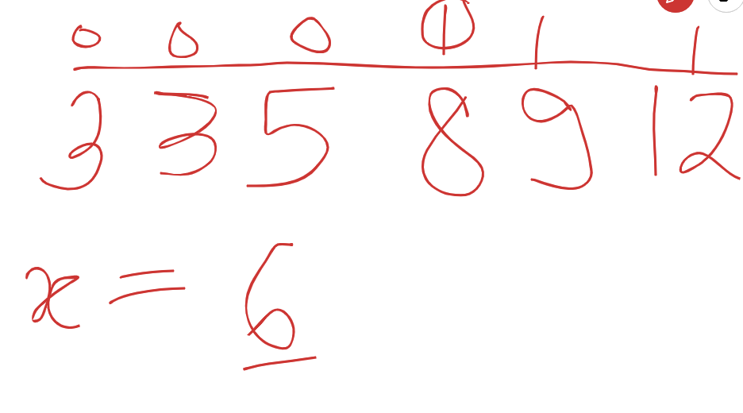

| #include <bits/stdc++.h>  using namespace std;  int main() {  int n, k;  cin >> n >> k;   vector<int> vec(n);   for (int i = 0; i < n; i++) {  cin >> vec[i];  }  int x;  while (k--) {  cin >> x;  int lo = 0, hi = n - 1;  int mid;  int ans = n;  while (lo <= hi) {  mid = lo + (hi - lo) / 2;  if (vec[mid] < x) {  lo = mid + 1;  } else {  ans = mid;  hi = mid - 1;  }  }  cout << ans + 1 << '\n';  }   return 0; } |
| --- |

HW: (Solve the 4 problems given here)  
<https://codeforces.com/edu/course/2/lesson/6/1/practice>

Q: <https://www.spoj.com/problems/EKO/>

N trees in a row: h1,h2,...hn

A woodcuter needs m length of wood

A[1...n] -> heights of trees

M

h-> height of the sawblade.

**Approach:**

Length of wood that mirka gets res= sum (max(0,a[i]-h)) ,1<=i<=n

If (res<m) -> h+1,h+2….. Are not possible

Else -> h can be your ans 1...h-1 are not required

l=0; -> cut all the trees completely

r=1e9; // log(10^9) = 9log10

**Sol:** n<=10^9

log(n)<log(1e9)

nlog(n)<nlog(1e9)

| int l=0,r=1e9,ans=0; // nlog(1e9) n<=10^6 logn<log(1e9)   while(l<=r){  int mid = l+(r-l)/2;  int res=0;  for(int i=0;i<n;i++){  if(a[i]>mid){  res+=a[i]-mid;  }  }  if(res>=m){ //mid is a possible ans  ans=mid;  l=mid+1;  }else{  r=mid-1;  }  }  cout<<ans; |
| --- |

**You can also think of the problem as :**

// Let us say height of sawblade = x

// Target : m metres of wood

// f(x) = 1, when you can get m metres of wood using a sawblade // of height x and 0, otherwise

x: 0 1 2 ... 7 8 ... 1e9

f(x): 1 1 1… 0 0 …. 0 [ Monotonically non-increasing ]

We need to find the last value of x for which f(x)=1.

**In case of binary search over floating point (decimal) values:**

double lo, hi;

const double eps = 0.000001; // or 1e-6;

while ( (hi - lo) > eps)

{  
…...   
}

**More practice problems:**

1. Solve all the problems here:

<https://codeforces.com/edu/course/2/lesson/6/2/practice>

2. <https://www.spoj.com/problems/AGGRCOW/>

3. <https://codeforces.com/problemset/problem/1195/B>

4. <https://codeforces.com/problemset/problem/1119/B>

5. <https://www.spoj.com/problems/NOTATRI/>

6. <https://atcoder.jp/contests/abc174/tasks/abc174_e>

7. <https://www.spoj.com/problems/PIE/>

8. <https://www.spoj.com/problems/HACKRNDM/>

9. <https://codeforces.com/problemset/problem/760/B>

10. <https://www.spoj.com/problems/BOOKS1/>